**WEEK-2**

Task-3

**Exercise 5: Return Data from a Stored Procedure**

**Goal:**

Create a stored procedure that returns the total number of employees in a

department.

**Steps:**

**1. Define the stored procedure with a parameter for DepartmentID.**

**2. Write the SQL query to count the number of employees in the**

**specified department.**

**3. Save the stored procedure by executing the Stored procedure**

**content.**

**CODE:**

DELIMITER $$

-- Create a stored procedure named 'sp_CountEmployeesByDepartment'

-- It takes one input parameter: dept_id (the ID of the department)

CREATE PROCEDURE sp_CountEmployeesByDepartment (

IN dept_id INT -- Input: DepartmentID to filter employees

)

BEGIN

-- Select the total number of employees in the specified department

SELECT

COUNT(*) AS TotalEmployees -- Returns the count as 'TotalEmployees'

FROM Employees

WHERE DepartmentID = dept_id; -- Filter by the input DepartmentID

END $$

-- Reset the statement delimiter back to default

DELIMITER ;

**Output**

-- Call the stored procedure with a sample DepartmentID (e.g., 3 for IT)

CALL sp_CountEmployeesByDepartment(3);

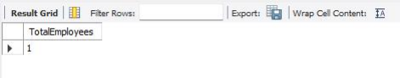

**Name:Ayushman Upadhyay**

**Email:2230164@kiit.ac.in**

**SuperSer ID: 6358125**